Aconex API: Use-Case overview

Intro

What is the Aconex API?
The Aconex API allows you to do things on Aconex via a program, rather than by visiting the website as a normal user. This means that you can automate tasks you would otherwise do manually.

Generally, What can it do?
Documents: | - List the documents in a project’s document register, search and filter the register for certain documents, see event log of a document, download documents out  - Update a document and its fields, upload a new document  - List/Add/Remove related items from documents
Mail: | - Get all the mail of a project, search/filter mail, download mail attachments. This includes getting the mail body, which you can’t do via any Aconex in-built reporting  - Create a new mail, create a draft, reply to/forward a mail, register mail. Create a new transmittal
Directory: | - Search a project directory for users. You can also search via email, which you can’t do on the webpage  - View an organisation’s org admins  - Get users in a mailing group, create/update/delete mailing group
Workflows: | - Search workflows of a project, including the documents, review outcome and comments  - Copy workflow template to another project
Field: | - List/create location areas  - List/create issue types  - List/filter issues, create/update an issue, get issue image attachments and comments  - List /filter inspection checklists, checklist items, and their attachments. Create/update checklist, including adding attachments/issues  - List/update inspection templates. Includes metadata on who made the template and when it was last updated. Get inspection template categories  - List/filter daily reports, create/update/submit daily report and add attachments. Export daily report
Tasks/Home Screen: | - Get your tasks for a project/all projects
Admin: | - Enable/disable a HB user’s account  - Get a HB user’s role assignment, create a new role, assign role to HB user  - View/create/edit/disable project fields of a project  - Copy a project  - Invite user to a project

What can it not do?
- You cannot code things that are triggered automatically by what’s happening on Aconex- e.g. you can’t run code every time a new transmittal is received, or every time a document is uploaded. You would have to schedule the program in order to achieve something similar
- You can’t mark documents as ‘no longer in use’
- You can’t send an ‘auto-update’ transmittal or look into transmittal histories of documents
- I don’t think you can register an incoming reply, you can only register a new mail. This is the same as the Aconex Outlook plugin
- You can’t mark a mail as closed-out
- You can’t search the global directory unless you already have the ID of the user – which you would only have if they were on a project. So you couldn’t use it to search for someone ‘new’
- Same as on the web, you can’t search for users who are hidden (i.e. if someone’s account is inactive, you can’t find them)
- You can’t start new workflows, end workflows, skip steps, etc.
- You can’t create new users, as it is connected to the Lobby rather than the Aconex API
- You can’t change the project settings in any way
This list could change as the Aconex API is updated roughly every quarter.

How does it work?
There are a few different types of API you can get.
- ‘User-bound’ – this is tied to one Aconex account, so any program you write will only use data from that account.
- ‘Non-interactive’ – within the program code, you specify which (Henry Brothers) Aconex account you want and use a certificate that verifies the user. This would allow you to write programs for specific users at Henry Brothers. I don’t understand how to implement this.
- ‘Web server’ – means that the program asks the user to log in when it runs. This would allow you to write a program that would work for any user at Henry Brothers
So far, I have used a user-bound API implementation on the ‘Early Access’ Aconex environment – this is a ‘test’ version with no real projects or data, tied to my account only.
To use the API on our real projects, we would need API access to the ‘UK1’ environment of Aconex, where our projects are stored.

Requirements to use
To use this we would need the following items approved:
Essential:
- Approval to request API access from Oracle Support for the UK1 environment of Aconex (as above)
- Python installed on the work computer running the code. Python is the programming language that I wrote my code examples in. You would need it installed to execute the code.
Nice to have:
- Pycharm (this is a platform to write Python code on)

Use-Cases

Directory

Managing new users
It is quite difficult to manage the project directory because there is no audit trail and everything has to be done manually. When adding new people to the project, it is easy to miss adding them to mailing groups. We use mailing groups to send information – the ‘All’ mailing group needs to be kept up to date with everyone on the project. If this is not correct, then we risk not giving a subcontractor the drawings/information they need. Similarly, site teams use subcontractor mailing groups to send EWs, Non-Conformances etc., rather than having to manually search and click each person’s name.
This program will take a list of users and a project, check that those users are on the project, then do the following:
- Add them to the ‘All’ mailing group (ensuring this is kept up to date)
- Add them to their company mailing group – either adding to an existing group, or creating a new one
- Draft an Aconex transmittal, attaching all the documents in the document register. An initial transmittal like this, is required to allow them to see the project files.
- Send a ‘Project Invite’ Aconex mail, based on a few pre-existing drafts set up in the project. These are generic mails we’ve been sending on new projects, to give new users a bit of context to Aconex, how it works, and the guides available for the project.

Next Steps
Because you can programmatically check and update these groups rather than manually, you could start to build up more mailing groups. E.g. we sometimes have a mailing group for the client team, the internal design team, a mailing group who we explicitly don’t send all information to (‘Non-All’ group), etc.
You could export that information and quickly create project directories for any project in excel.
Similarly, I have an excel spreadsheet that tracks who I’m currently working on adding to a project. This program could automatically update that tracker.

Workflows

Exporting selected comments
There are some exporting features built into the Workflows tab, but it can be difficult to follow because it is not sorted by document. You can’t easily see per document the different revisions of the file, and the comments made for each revision.
We made a nice tracker for the Sacred Heart project in the Insights tab to display this, but one of the problems we had with the client is that we would send a batch of new revisions, and they would want to see the comments made on the previous revisions. We could give them the comments for all files but couldn’t filter to just those particular drawings. Because of the way you make reports in the Insights tab, it exported very poorly to excel, so couldn’t then be quickly manually filtered that way.
This is very easily solved with the API. The program takes a project, and a list of document numbers, and searches for all the workflows those documents have been in. It then exports the data into excel, listing each document, each revision, and the comments.
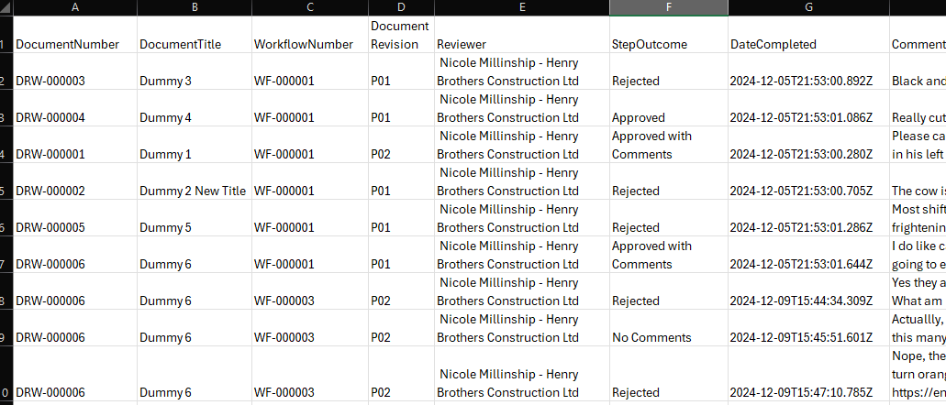

Next Steps
This is a very simple export to excel, but the spreadsheet could easily be formatted to make it better to read. And because it exports nicer than the Insights tab, it can be filtered down further, or displayed graphically.
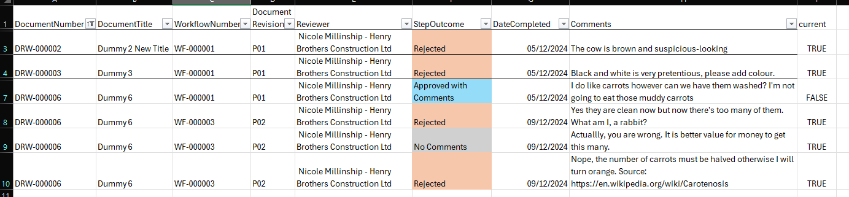
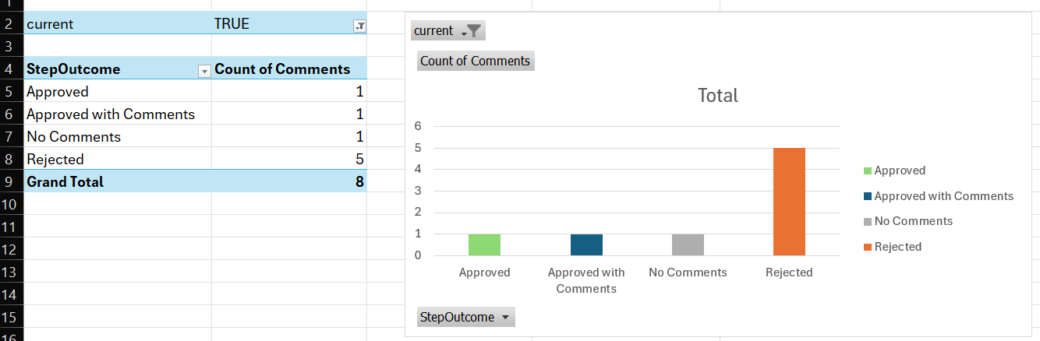

Field

Renaming
The Field Inspections tab is not very nice to search through, especially as a project progresses and you have 100s of the same type of permit.
This program cycles through the Field inspections and renames them based on the data within the inspection. The new title could be structured in different ways to suit—in this example, the permits are renamed to Permit type – Company (description of works). The environmental weekly checks are renamed to include the week commencing date.
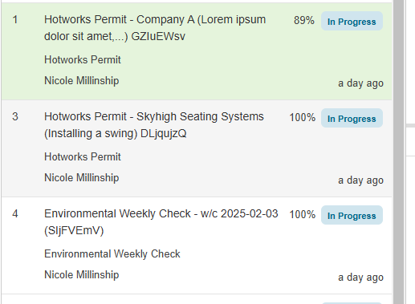
I have also put in a random ID for each inspection (e.g. GZIuEWsv). This is because when you try to search by inspection number (e.g. inspection number 2), you will get any inspection with the number 2 anywhere in the inspection, making it very useless. An ID like this would allow you to identify and search for any individual inspection.

Exporting into our templates
There are occasions (e.g. for accident reporting, etc.) when the inspections on Field have to be exported out. They export into very long reports.
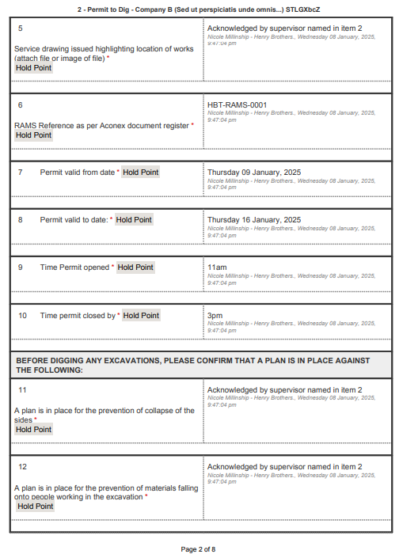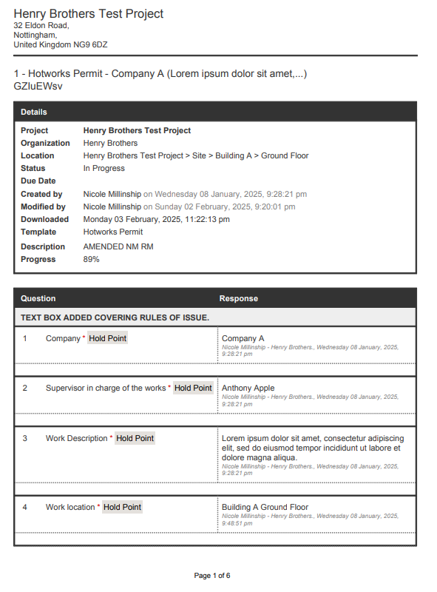
In our IMS manual we have pdf versions of the permits with form fields built in. With a few tweaks to the pdf form to account for the differences between the pdf and the Aconex Field template, you can load the data into the pdf form.
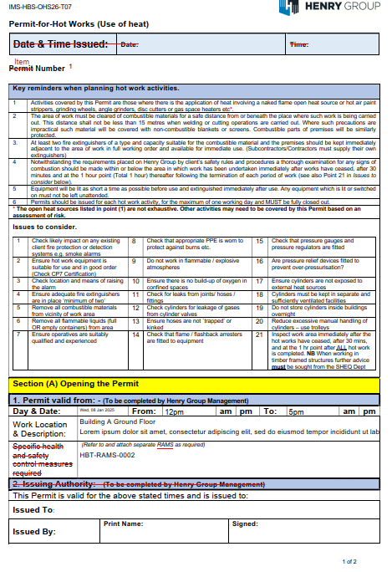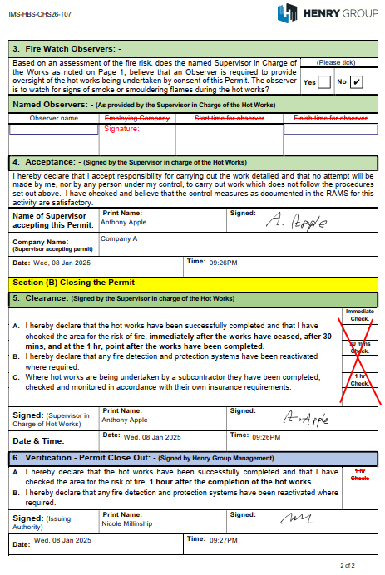

More Ideas (not implemented)
Here is some other things I think are possible with the API:
Documents:
- Aconex handles DWGs really badly because they’re treated as a separate entity to the pdf. The related items feature is a way of tying two files in the register together, but it would be really time-consuming to connect each pdf and dwg every time you uploaded. Another problem is that typically, the dwg is not updated as often as the pdf, so the dwg is not necessarily the latest version of the drawing, which can cause confusion. You could automate the connection of these two files and then have a field that says whether the dwg is as up to date as the pdf.
- We have ‘date modified’ as an automatic piece of metadata but we can’t display ‘date revised’ in the document register. This is annoying because the date modified is changed every time anything happens to the item in the register (i.e. fixing a typo, sending in a workflow, etc.). What people actually want to see is the date that that revision was first uploaded onto Aconex. We could add this manually as a document field but I think it would be plagued with mistakes and would then be quite time-consuming to check it was correct. But since this data is stored behind the scenes, we could run code to fill this field in.
- We have a lot of files now in the register that are marked as confidential so that they aren’t shared out to subcontractors. However whenever someone new from Henry Brothers gets added to the project, you have to go find each confidential file and update the confidentiality list so they can see these files. Doing this automatically would be helpful.
- We put the H&S and Q&E audits in the doc register, I put the score in the comments box. Simple graph of a project’s H&S / Q&E historical audit scores could be more insightful in the IPR than just a number.
Mail:
- We have RFI trackers on the Insights tab but they are a bit confusing because RFIs get forwarded between parties which confuses the ‘logic’ of the Insights report. I think you could export a much clearer RFI tracker using the API, and you’d also be able to add hyperlinks to the Mail.
- ‘Weekly update mail’s – we sort of do this already with sending weekly workflow trackers and RFI trackers via email, but we could have code that runs every week that lists out- workflows outstanding, RFIs outstanding, EWs sent, transmittals sent, etc. It could become a focus point that avoids people feeling bombarded and overwhelmed with different notifications.
Field:
- Ability to ‘duplicate’ Field inspections. For example, if you were creating the same hotworks permit every day for some company, you could have it fill in the first few questions for you. This could save the site teams time and not hold up the subcontractor for as long before they can start work.
- I think the weather section of Daily Reports is a bit pointless because you can get historical weather data at any time, but, if it needs to be filled in – we could definitely pull that data and put it into the report
- In general – better exporting and data analysis. You could make reports about each company, all the people inducted for that company, etc. etc.

Security
Below is the list of risks associated with API access.

Account Access
In order to connect the account to the API, you are given a ‘Secret’ key (i.e. a password) that you use to authenticate yourself when you communicate with the API within the program.
If the ‘Secret’ key was shared, it could be used by someone else to interact with the API, giving them access to get and update data on projects tied to the account. Essentially it is a similar scenario to giving someone your Aconex password / details to log into your account.

How to Mitigate
The only method is to not share the program, which has the key inside the code. If it was shared and there was a concern, we would have to ask Oracle Support to delete / change the Secret key.

Bulk-Requests
If the code was written incorrectly, you could risk sending 100s+ Aconex mails, for example, or mass-updating documents incorrectly, or creating 100s of Field Inspections. Although you can make a mistake on the webpage, the chance of making a mistake in code (e.g. sending documents to the wrong person, uploading the wrong document) is higher.

How to Mitigate
- The API has a built-in ‘limit’ to how many requests you can make, preventing you from sending 100 Mails a second, for example.
- Thoroughly test everything in the Early Access environment first before running on UK1
- Draft Mail, rather than explicitly send Mail. This way it can be checked before it’s sent out.
- Although you can invite users using the API, it may be better to not use this at all, bearing in mind that organisations cannot be removed from projects.

More Information
- General Support Central page on the API
- More details on the user-bound API integration

